Name: Date: Open syllables

When the long (u) sound comes at the end of a syllable within a word, it is usually represented by the letter u on its own.

Remember: Say the word aloud, then say each letter aloud as you write it e.g. 'human, h ... u ... m ... a ... n'

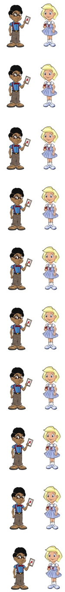
Each person is a human (hu/man).

A pupil (pu/pil) is a child at school.

If someone is stupid (stu/pid), they are not very clever.

A unit (u/nit) is just one.

In music (mu/sic) you learn to sing and play instruments.

A student (stu/dent) is a person at university or college.

A tulip (tu/lip) is a type of flower.

If you educate (ed/u/cate) someone, you teach them.

A menu (men/u) tells you what you can eat in a restaurant.

Now test yourself without looking at the words and check for yourself if you got them all right. Practice writing any words that you made mistakes on again.

© www.SaveTeachersSundays.com 2013
Name: Date: Open syllables

When the long (u) sound comes at the end of a syllable within a word, it is usually represented by the letter u on its own.

Remember: Say the word aloud, then say each letter aloud as you write it e.g. 'human, h ... u ... m ... a ... n'

Try to spell each word without looking at it.

Each person is a .

A is a child at school.

If someone is , they are not very clever.

A is just one.

In you learn to sing and play instruments.

A is a person at university or college.

A is a type of flower.

If you someone, you teach them.

A tells you what you can eat in a restaurant.

Now check for yourself if you got them all right. Practice writing any words that you made mistakes on again.

© www.SaveTeachersSundays.com 2013

